

Proposal of Job Mate

Ayush Shrestha

BSc. (Hons.) Computing, Softwarica College of IT & E-Commerce

ST6003CEM Web API Development

Bimal Shrestha

Table of Contents

Job Mate: Hiring made easy 4

Justification (Background and Inspiration) 5

Project Objectives 6

After project completion and Project mission 7

Scope of work (What technology is used) 8

Features Of Job Mate 10

Prototype 11

Conclusion 15

References 16

Table of Figure

**Figure 1** Prototype of Home Screen 10

**Figure 2** Prototype of Job Post Builder Screen 10

**Figure 3** Prototype of Progress Tracking Screen 11

**Figure 4** Prototype of Progress Tracking Screen With Status 11

**Figure 5** Prototype of Edit Profile Screen 11

# Job Mate: Hiring made easy

Platforms that simplify hiring are desperately needed in the quickly changing digital employment market. The goal of this project is to create a comprehensive job-hiring web application that will make it easier for employers and candidates to communicate with each other. Companies will have the ability to advertise job openings, monitor applications, and manage the progress of candidates in the pipeline, whereas the candidates will have the ability to check out job openings, create resumes and submit resumes. By making the employment process more effective, this application hopes to facilitate a more seamless transfer for all parties.

# Justification (Background and Inspiration)

In today's competitive job market, the traditional methods of recruitment are often inefficient and cumbersome, both for employers seeking the right talent and for job seekers trying to find suitable positions. Many existing job platforms fail to provide comprehensive tools for tracking and managing the recruitment process effectively. Employers face challenges in organizing and updating the statuses of numerous applicants, which can lead to delays and communication gaps (Bika, 2023). On the other hand, job seekers frequently struggle with lack of transparency and feedback on their application status.

Job Mate is conceived to address these inefficiencies by offering a robust and intuitive web application that enables employers to not only post job listings but also to manage and communicate with applicants seamlessly through every stage of the hiring process. The aim is to streamline recruitment, enhance interaction between hiring teams and candidates, and ultimately improve the hiring experience for all parties involved. This platform will ensure greater efficiency, increased transparency, and better management of recruitment processes, aligning with the needs of modern workplaces.

# Project Objectives

1. Master the MERN Stack: Gain a deep understanding of how MongoDB, Express.js, React, and Node.js interact within the application.
2. Advanced User Management: Enable profile creation, job postings, resume building and application management through a robust backend.
3. Real-Time Communication: Implement updates and notifications to keep users informed about job and application statuses.
4. Efficient Project Management: Ensure timely project execution to meet deadlines.
5. Intuitive User Interface: Design a straightforward interface for an easy user experience in job management.

# After project completion and Project mission

After completing the Job Mate project, our mission to refine the recruitment process continues. The platform will prioritize ongoing user support and enhancements based on user feedback, aiming to streamline the connection between employers and job seekers. Job Mate will evolve by expanding features, enhancing interfaces, and maintaining rigorous data security standards. Continuous development will include new functionalities and integrations to ensure the platform remains transparent, accessible, and effective. Our commitment is to transform the hiring landscape, making it more efficient and user-centric, thereby improving the recruitment experience for all users.

# Scope of work (What technology is used)

Here are the scope of the work for Job Mate.

* **User-Driven Interface**: Designs are centered around the user’s requirements to ensure the web application is intuitive and user-friendly, significantly enhancing user satisfaction.
* **Iterative Development**: Adopts iterative approaches using agile practices to refine and evolve the platform continually based on real-time user feedback.
* **Enhanced Security Measures**: Prioritizes robust data protection strategies, enhancing security measures to safeguard user data and ensure strict confidentiality.
* **Continuous User Feedback**: Proactively incorporates user input into the development lifecycle to tailor and optimize the functionality and user experience of the platform.

Here is a list of technology that will be used in building Job Mate:

* **MongoDB (Database)**: Utilized to store job listings, applicant data, and employer profiles, providing a scalable structure for data management.
* **Express.js (Backend Framework)**: Handles server-side logic, routing, and API development, ensuring effective communication between the frontend and database.
* **React (Frontend Framework)**: Used for developing the user interface, enabling interactive and dynamic web pages for an enhanced user experience.
* **Node.js (Server Environment)**: Executes server-side scripts and manages interactions with the database, supporting real-time data retrieval and user authentication.

# Features Of Job Mate

Job Mate will have the following features integrated in it:

1.Job Creating Interface: Streamlined tools for employers to create, edit, and manage job listings

efficiently.

2.Job Post Viewing interface (For companies): Job seekers can view all the current open Job listings, along with more details about the Job post (For example: Who applied to the job).

3. Job Post Viewing interface (For candidates): Candidates can view all the job openings, along with more details about the Job post (For example: type of job, who posted the job, what’s the role etc.).

4. Hiring pipeline tracking: A system to monitor the candidate statuses (e.g., interviewed,

shortlisted, hired) through the recruitment process.

5. Real-Time Notifications: Instant updates for employers on application

statuses

6. Profile Management: Customizable profiles that store essential information of job seekers employers.

7. Resume creation: Candidates will be effortlessly able to build resumes and then get it in a pdf format.

8. Resume submission portal: Candidates will have the ability to submit their resumes to the jobs they want to apply to.

# Prototype

To develop Job Mate, the first step is to create a Prototype. A prototype is a mockup of what the

finished product will look like. Developing a Prototype first helped tremendously in setting the vision for the UI of Job Mate and gave a clearer perspective at the features that will be included (Douglas, 2023).

**Figure 1**  
Prototype of Home Screen

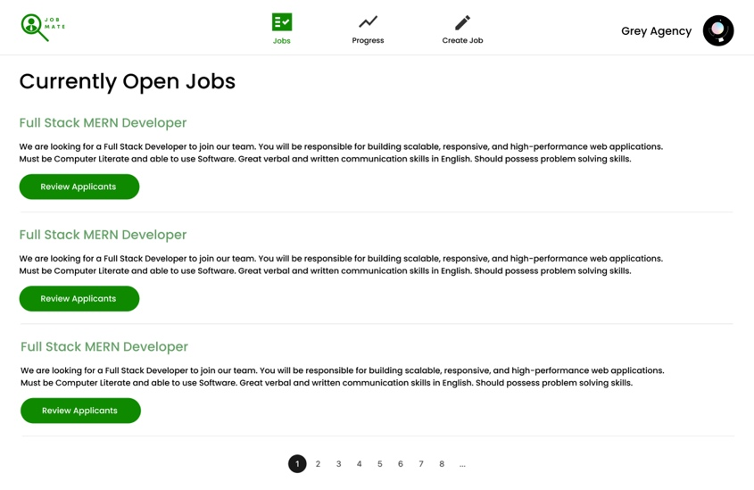

**Figure 2**  
Prototype of Job Post Builder Screen

**Figure 3**  
*Prototype of Progress Tracking Screen*

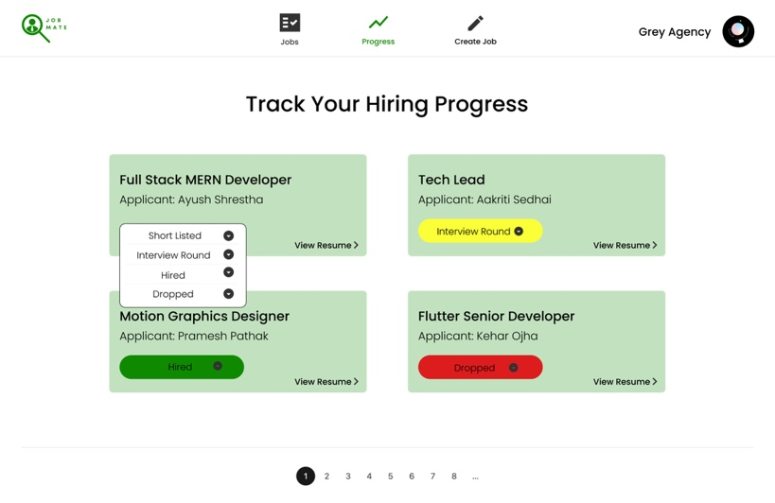

**Figure 4**  
*Prototype of Progress Tracking Screen With Status*

**Figure 5**  
Prototype of Edit Profile Screen

# Conclusion

Job Mate showcases the transformative impact of technology in recruitment. Beyond basic job postings, it offers features like hiring pipeline tracking, managing user profile and real time notifications. Its commitment to user privacy ensures that personal data enhances the hiring process while upholding the highest security standards. As the job market evolves, Job Mate equips users with effective tools and contributes to the broader discussion on technology’s role in employment. It serves as a beacon of innovation, demonstrating how digital solutions can usher in a new era of streamlined, informed recruitment practices for all stakeholders.

# References

*Douglas, C. (2023, December 18). Benefits of prototyping - visily. Visily.* [*https://www.visily.ai/blog/benefits-of-prototyping/*](https://www.visily.ai/blog/benefits-of-prototyping/)

*Bika, N. (2023, September 26). The most common recruiting challenges and how to overcome them. Recruiting Resources: How to Recruit and Hire Better. https://resources.workable.com/stories-and-insights/common-recruiting-challenges*